https://css-tricks.com/snippets/css/complete-guide-grid/:
A Complete Guide to GRID (css-tricks.com)

CSS Grid Layout is the most powerful layout system available in CSS. It is a 2-dimensional system, meaning it can handle both columns and rows, unlike flexbox which is largely a 1-dimensional system. You work with Grid Layout by applying CSS rules both to a parent element (which becomes the Grid Container) and to that element’s children (which become Grid Items).
This article was ported over from Chris House's guide, by Chris himself, who is keeping both up-to-date.

Introduction
CSS Grid Layout (aka "Grid"), is a two-dimensional grid-based layout system that aims to do nothing less than completely change the way we design grid-based user interfaces. CSS has always been used to lay out our web pages, but it's never done a very good job of it. First we used tables, then floats, positioning and inline-block, but all of these methods were essentially hacks and left out a lot of important functionality (vertical centering, for instance). Flexbox helped out, but it's intended for simpler one-dimensional layouts, not complex two-dimensional ones (Flexbox and Grid actually work very well together). Grid is the very first CSS module created specifically to solve the layout problems we've all been hacking our way around for as long as we've been making websites.
There are two primary things that inspired me to create this guide. The first is Rachel Andrew's awesome book Get Ready for CSS Grid Layout. It's a thorough, clear introduction to Grid and is the basis of this entire article. I highly encourage you to buy it and read it. My other big inspiration is Chris Coyier's A Complete Guide to Flexbox, which has been my go-to resource for everything flexbox. It's helped a ton of people, evident by the fact that it's the top result when you Google "flexbox." You'll notice many similarities between his post and mine, because why not steal from the best?
My intention with this guide is to present the Grid concepts as they exist in the very latest version of the specification. So I won't be covering the out of date IE syntax, and I'll do my best to update this guide regularly as the spec matures.

Basics and Browser Support
To get started you have to define a container element as a grid with display: grid, set the column and row sizes with grid-template-columns and grid-template-rows, and then place its child elements into the grid with grid-column and grid-row. Similarly to flexbox, the source order of the grid items doesn't matter. Your CSS can place them in any order, which makes it super easy to rearrange your grid with media queries. Imagine defining the layout of your entire page, and then completely rearranging it to accommodate a different screen width all with only a couple lines of CSS. Grid is one of the most powerful CSS modules ever introduced.
As of March 2017, many browsers shipped native, unprefixed support for CSS Grid: Chrome (including on Android), Firefox, Safari (including on iOS), and Opera. Internet Explorer 10 and 11 on the other hand support it, but it's an old implementation with an outdated syntax. Edge support has been announced, but it's not here yet.
This browser support data is from Caniuse, which has more detail. A number indicates that browser supports the feature at that version and up.
#Desktop
Chrome | Opera | Firefox | IE | Edge | Safari
57 | 44 | 52 | 11* | 16 | 10.1

#Mobile/Tablet
iOS Safari | Opera Mobile | Opera Mini | Android | Android Chrome | Android Firefox
10.3 | No | No | 62 | 62 | 57

Aside from Microsoft, browser manufacturers appear to be holding off on letting Grid loose in the wild until the spec is fully cooked. This is a good thing, as it means we won't have to worry about learning multiple syntaxes.
It's only a matter of time before you can use Grid in production. But the time to learn it is now.

Important Terminology
Before diving into the concepts of Grid it's important to understand the terminology. Since the terms involved here are all kinda conceptually similar, it's easy to confuse them with one another if you don't first memorize their meanings defined by the Grid specification. But don't worry, there aren't many of them.

#Grid Container
The element on which display: grid is applied. It's the direct parent of all the grid items. In this example container is the grid container.
html
<div class="container">
<div class="item item-1"></div>
<div class="item item-2"></div>
<div class="item item-3"></div>
</div>

#Grid Item
The children (e.g. direct descendants) of the grid container. Here the item elements are grid items, but sub-item isn't.
html
<div class="container">
<div class="item"></div>
<div class="item></div>
<p class="sub-item></p>
<div>
<div class="item"></div>
</div>

#Grid Line
The dividing lines that make up the structure of the grid. They can be either vertical ("column grid lines") or horizontal ("row grid lines") and reside on either side of a row or column. Here the yellow line is an example of a column grid line.
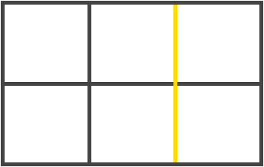

#Grid Track
The space between two adjacent grid lines. You can think of them like the columns or rows of the grid. Here's the grid track between the second and third row grid lines.
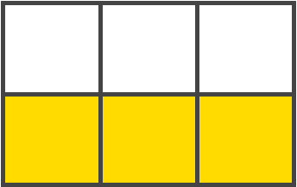

#Grid Cell
The space between two adjacent row and two adjacent column grid lines. It's a single "unit" of the grid. Here's the grid cell between row grid lines 1 and 2, and column grid lines 2 and 3.
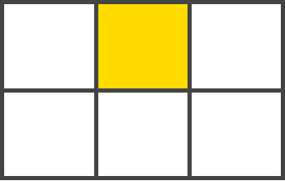

#Grid Area
The total space surrounded by four grid lines. A grid area may be comprised of any number of grid cells. Here's the grid area between row grid lines 1 and 3, and column grid lines 1 and 3.
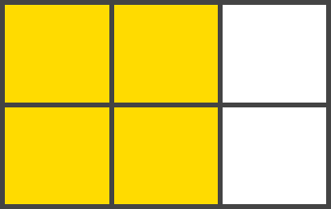

Grid Properties Table of Contents

Properties for the Parent (Grid Container)

#display
Defines the element as a grid container and establishes a new grid formatting context for its contents.
Values:
- grid - generates a block-level grid
- inline-grid - generates an inline-level grid
- subgrid - if your grid container is itself a grid item (i.e. nested grids), you can use this property to indicate that you want the sizes of its rows/columns to be taken from its parent rather than specifying its own.
css
.container {
display: grid | inline-grid | subgrid;
}
Note: column, float, clear, and vertical-align have no effect on a grid container.

#grid-template columns, grid-template-rows
Defines the columns and rows of the grid with a space-separated list of values. The values represent the track size, and the space between them represents the grid line.
Values:
- <track-size> - can be a length, a percentage, or a fraction of the free space in the grid (using the fr unit)
- <line-name> - an arbitrary name of your choosing
css
.container {
grid-template-columns: <track-size> ... | <line-name> <track-size> ...;
grid-template-rows: <track-size> ... | <line-name> <track-size> …;
}

Examples:
When you leave an empty space between the track values, the grid lines are automatically assigned numerical names:
css
.container {
grid-template-columns: 40px 50px auto 50px 40px;
grid-template-rows: 25% 100px auto;
}

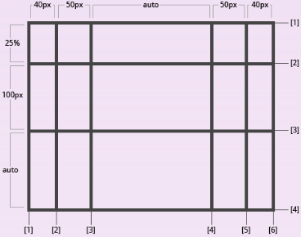
But you can choose to explicitly name the lines. Note the bracket syntax for the line names:
css
.container {
grid-template-columns: [first] 40px [line2] 50px [line3] auto [col4-start] 50px [five] 40px [end];
grid-template-rows: [row1-start] 25% [row1-end] 100px [third-line] auto [last-line];
}

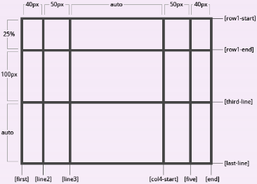
Note that a line can have more than one name. For example, here the second line will have two names: row1-end and row2-start:
css
.container {
grid-template-rows: [row1-start] 25% [row1-end row2-start] 25% [row2-end];
}

If your definition contains repeating parts, you can use the repeat() notation to streamline things:
css
.container {
grid-template-columns: repeat(3, 20px [col-start]) 5%;
}

Which is equivalent to this:
css
.container {
grid-template-columns: 20px [col-start] 20px [col-start] 20px [col-start] 5%;
}

The fr unit allows you to set the size of a track as a fraction of the free space of the grid container. For example, this will set each item to one third the width of the grid container:
css
.container {
grid-template-columns: 1fr 1fr 1fr;
}

The free space is calculated after any non-flexible items. In this example the total amount of free space available to the fr units doesn't include the 50px:

css
.container {
grid-template-columns: 1fr 50px 1fr 1fr;
}

#grid-template-areas
Defines a grid template by referencing the names of the grid areas which are specified with the grid-area property. Repeating the name of a grid area causes the content to span those cells. A period signifies an empty cell. The syntax itself provides a visualization of the structure of the grid.
Values:
- <grid-area-name> - the name of a grid area specified with grid-area
- . - a period signifies an empty grid cell
- none - no grid areas are defined
css
.container {
grid-template-areas:
”<grid-area-name> | . | none | ...”
”...”;
}

Examples:
css
.item-a {
grid- areas: heder;
}
.item-b {
grid- areas: main;
}
.item-c {
grid- areas: sidebar;
}
.item-d {
grid- areas: footer;
}
.container {
grid-template-columns: 50px 50px 50px 50px;
grid-template-rows: auto;
grid-template-areas:
”header header header header”
”main main . sidebar”
”footer footer footer footer”;
}

That'll create a grid that's four columns wide by three rows tall. The entire top row will be comprised of the header area. The middle row will be comprised of two main areas, one empty cell, and one sidebar area. The last row is all footer.
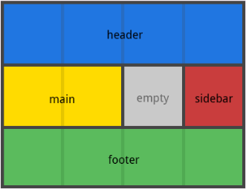
Each row in your declaration needs to have the same number of cells.
You can use any number of adjacent periods to declare a single empty cell. As long as the periods have no spaces between them they represent a single cell.
Notice that you're not naming lines with this syntax, just areas. When you use this syntax the lines on either end of the areas are actually getting named automatically. If the name of your grid area is foo, the name of the area's starting row line and starting column line will be foo-start, and the name of its last row line and last column line will be foo-end. This means that some lines might have multiple names, such as the far left line in the above example, which will have three names: header-start, main-start, and footer-start.

#grid-template
A shorthand for setting grid-template-rows, grid-template-columns, and grid-template-areas in a single declaration.
Values:
- none - sets all three properties to their initial values
- subgrid - sets grid-template-rows and grid-template-columns to subgrid, and grid-template-areas to its initial value
- <grid-template-rows> / <grid-template-columns> - sets grid-template-columns and grid-template-rows to the specified values, respectively, and sets grid-template-areas to none
css
.container {
grid-template: none | subgrid | <grid-template-rows> / <grid-template-columns>;
}

It also accepts a more complex but quite handy syntax for specifying all three. Here's an example:
css
.container {
grid-template:
[row1-start] ”header header header header” 25px [row1-end]
[row2-start] ”footer footer footer footer” 25px [row1-end]
/ auto 50px auto;
}

That's equivalent to this:
css
.container {
grid-template-rows: [row1-start] 25px [row1-end row2-start] 25px [row2-end};
grid-template-columns: auto 50px auto;
grid-template-areas:
”header header header header”
”footer footer footer footer”;
}

Since grid-template doesn't reset the implicit grid properties (grid-auto-columns, grid-auto-rows, and grid-auto-flow), which is probably what you want to do in most cases, it's recommended to use the grid property instead of grid-template.

#grid-column-gap, grid-row-gap
Specifies the size of the grid lines. You can think of it like setting the width of the gutters between the columns/rows.
Values:
- <line-size> - a length value
css
.container {
grid-column-gap: <line-size>;
grid-row-gap: <line-size>;
}

Examples:
css
.container {
grid-template-columns: 100px 50px 100px;
grid-template-rows: 80px auto 80px;
grid-column-gap: 10px;
grid-row-gap: 15px;
}

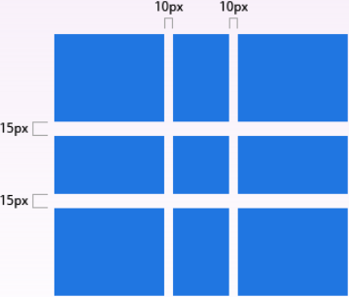
The gutters are only created between the columns/rows, not on the outer edges

#grid-gap
A shorthand for grid-row-gap and grid-column-gap
Values:
- <grid-row-gap> <grid-column-gap> - length values
css
.container {
grid-gap: <grid-row-gap> <grid-column-gap>;
}

Examples:
css
.container {
grid-template-columns: 100px 50px 100px;
grid-template-rows: 80px auto 80px;
grid-gap: 10px 15px;
}

If no grid-row-gap is specified, it's set to the same value as grid-column-gap

#justify-items
Aligns the content inside a grid item along the row axis (as opposed to align-items which aligns along the column axis). This value applies to all grid items inside the container.
Values:
- start - aligns the content to the left end of the grid area
- end - aligns the content to the right end of the grid area
- center - aligns the content in the center of the grid area
- stretch - fills the whole width of the grid area (this is the default)
css
.container {
justify-items: start;
}

Examples:
css
.container {
justify-items: start;
}

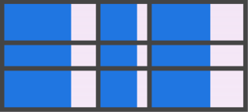
css
.container {
justify-items: end;
}

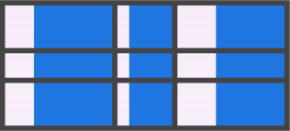
css
.container {
justify-items: center;
}

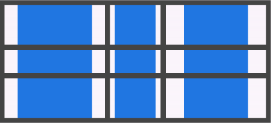
css
.container {
justify-items: stretch;
}

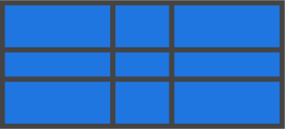
This behavior can also be set on individual grid items via the justify-self property.

#align-items
Aligns the content inside a grid item along the column axis (as opposed to justify-items which aligns along the row axis). This value applies to all grid items inside the container.
Values:
- start - aligns the content to the top of the grid area
- end - aligns the content to the bottom of the grid area
- center - aligns the content in the center of the grid area
- stretch - fills the whole height of the grid area (this is the default)
css
.container {
align-items: start | end | center | stretch;
}

Examples:
css
.container {
align-items: start;
}

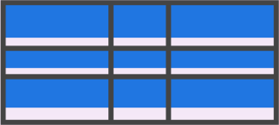
css
.container {
align-items: end;
}

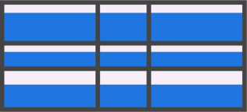
css
.container {
align-items: center;
}

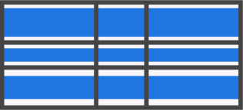
css
.container {
align-items: stretch;
}

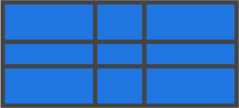
This behavior can also be set on individual grid items via the align-self property.

#justify-content
Sometimes the total size of your grid might be less than the size of its grid container. This could happen if all of your grid items are sized with non-flexible units like px. In this case you can set the alignment of the grid within the grid container. This property aligns the grid along the row axis (as opposed to align-content which aligns the grid along the column axis).
Values:
- start - aligns the grid to the left end of the grid container
- end - aligns the grid to the right end of the grid container
- center - aligns the grid in the center of the grid container
- stretch - resizes the grid items to allow the grid to fill the full width of the grid container
- space-around - places an even amount of space between each grid item, with half-sized spaces on the far ends
- space-between - places an even amount of space between each grid item, with no space at the far ends
- space-evenly - places an even amount of space between each grid item, including the far ends
css
.container {
justify-content: start | end | center | stretch;
}

Examples:
css
.container {
justify-content: start;
}
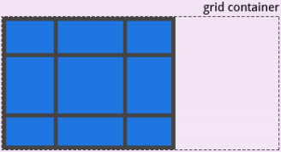
css
.container {
justify-content: end;
}
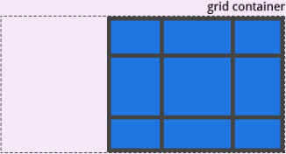
css
.container {
justify-content: center;
}
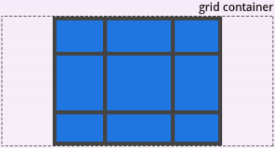
css
.container {
justify-content: stretch;
}
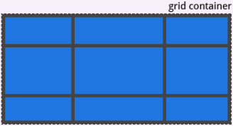
css
.container {
justify-content: space-around;
}
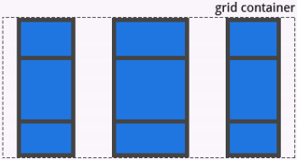
css
.container {
justify-content: space-between;
}
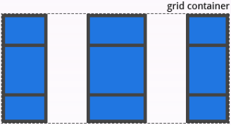

#align-content
Sometimes the total size of your grid might be less than the size of its grid container. This could happen if all of your grid items are sized with non-flexible units like px. In this case you can set the alignment of the grid within the grid container. This property aligns the grid along the column axis (as opposed to justify-content which aligns the grid along the row axis).
Values:
- start - aligns the grid to the top of the grid container
- end - aligns the grid to the bottom of the grid container
- center - aligns the grid in the center of the grid container
- stretch - resizes the grid items to allow the grid to fill the full height of the grid container
- space-around - places an even amount of space between each grid item, with half-sized spaces on the far ends
- space-between - places an even amount of space between each grid item, with no space at the far ends
- space-evenly - places an even amount of space between each grid item, including the far ends
css
.container {
align-content: start | end | center | stretch | space-around | space-between | space-evenly;
}

Examples:
css
.container {
align-content: start;
}
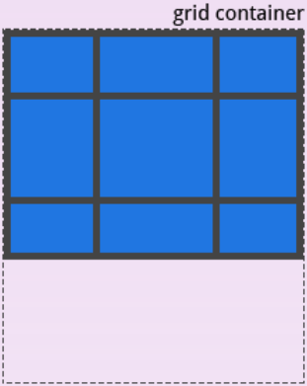
css
.container {
align-content: end;
}
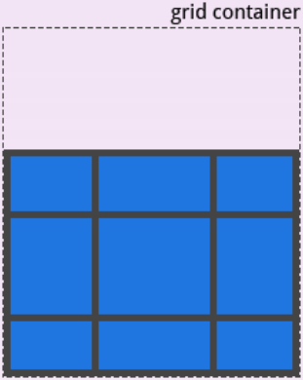
css
.container {
align-content: center;
}
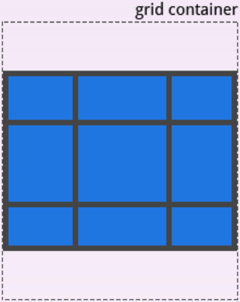
css
.container {
align-content: stretch;
}
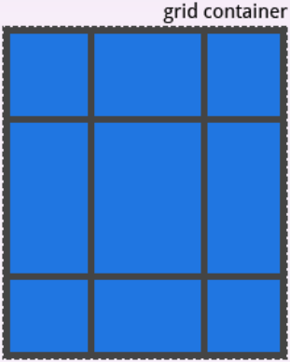
css
.container {
align-content: space-around;
}
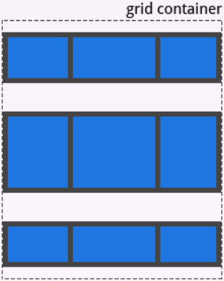
css
.container {
align-content: space-between;
}
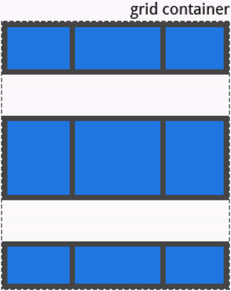
css
.container {
align-content: space-evenly;
}
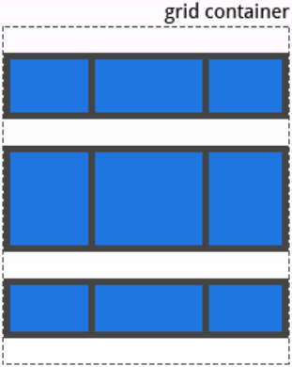

#grid-auto-columns, grid-auto-rows
Specifies the size of any auto-generated grid tracks (aka implicit grid tracks). Implicit grid tracks get created when you explicitly position rows or columns (via grid-template-rows/grid-template-columns) that are out of range of the defined grid.
Values:
- <track-size> - can be a length, a percentage, or a fraction of the free space in the grid (using the fr unit)
css
.container {
grid-auto-columns: <track-size> ...;
grid-auto-rows: <track-size> ...;
}

To illustrate how implicit grid tracks get created, think about this:
css
.container {
grid-template-columns: 60px 60px;
grid-template-rows: 90px 90px;
}
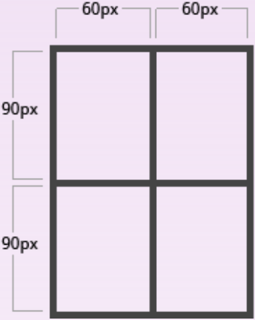
This creates a 2 x 2 grid.
But now imagine you use grid-column and grid-row to position your grid items like this:
css
.item-a {
grid-column: 1 / 2;
grid-row: 2 / 3;
}
.item-b {
grid-column: 5 / 6;
grid-row: 2 / 3;
}
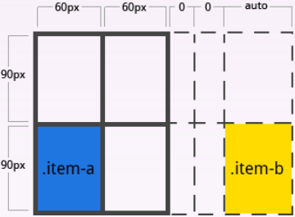
We told .item-b to start on column line 5 and end at column line 6, but we never defined a column line 5 or 6. Because we referenced lines that don't exist, implicit tracks with widths of 0 are created to fill in the gaps. We can use grid-auto-columns and grid-auto-rows to specify the widths of these implicit tracks:
css
.container {
grid-auto-column: 60px;
}
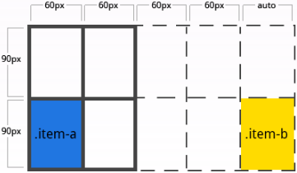

#grid-auto-flow
If you have grid items that you don't explicitly place on the grid, the auto-placement algorithm kicks in to automatically place the items. This property controls how the auto-placement algorithm works.
Values:
- row - tells the auto-placement algorithm to fill in each row in turn, adding new rows as necessary
- column - tells the auto-placement algorithm to fill in each column in turn, adding new columns as necessary
- dense - tells the auto-placement algorithm to attempt to fill in holes earlier in the grid if smaller items come up later
css
.container {
grid-auto-flow: row | column | row dense | column dense
}

Note that dense might cause your items to appear out of order.
Examples:
Consider this HTML:
html
<section container”>
<div class=”item-a”>item-a</div>
<div class=”item-b”>item-b</div>
<div class=”item-c”>item-c</div>
<div class=”item-d”>item-d</div>
<div class=”item-e”>item-e</div>
</section

You define a grid with five columns and two rows, and set grid-auto-flow to row (which is also the default):
css
.container {
display: grid;
grid-template-columns: 60px 60px 60px 60px 60px;
grid-template-rows: 30px 30px;
grid-auto-flow: row;
}

When placing the items on the grid, you only specify spots for two of them:
css
.item-a {
grid-column: 1;
grid-row: 1 / 3;
}
.item-b {
grid-column: 5;
grid-row: 1 / 3;
}

Because we set grid-auto-flow to row, our grid will look like this. Notice how the three items we didn't place (item-b, item-c and item-d) flow across the available rows:
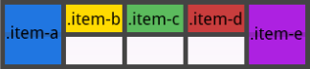
If we instead set grid-auto-flow to column, item-b, item-c and item-d flow down the columns:
css
.container {
display: grid;
grid-template-columns: 60px 60px 60px 60px 60px;
grid-template-rows: 30px 30px;
grid-auto-flow: column;
}

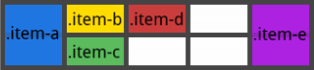

#grid
A shorthand for setting all of the following properties in a single declaration: grid-template-rows, grid-template-columns, grid-template-areas, grid-auto-rows, grid-auto-columns, and grid-auto-flow. It also sets grid-column-gap and grid-row-gap to their initial values, even though they can't be explicitly set by this property.
Values:
- none - sets all sub-properties to their initial values
- <grid-template-rows> / <grid-template-columns> - sets grid-template-rows and grid-template-columns to the specified values, respectively, and all other sub-properties to their initial values
- <grid-auto-flow> [<grid-auto-rows> [ / <grid-auto-columns>] ] - accepts all the same values as grid-auto-flow, grid-auto-rows and grid-auto-columns, respectively. If grid-auto-columns is omitted, it is set to the value specified for grid-auto-rows. If both are omitted, they are set to their initial values
css
.container {
grid: none | <grid-template-rows> / <grid-template-columns> | <grid-auto-flow> [<grid-auto-rows> [/ <grid-auto-columns>]];
}

Examples:
The following two code blocks are equivalent:
css
.container {
grid: 200px auto / 1fr auto 1fr;
}

css
.container {
grid-template-rows: 200px auto;
grid-template-columns: 1fr auto 1fr;
grid-template-areas: none;
}

And the following two code blocks are equivalent:
css
.container {
grid: column 1fr auto;
}

css
.container {
grid-auto-flow: column;
grid-auto-rows: 1fr;
grid-auto-columns: auto;
}

It also accepts a more complex but quite handy syntax for setting everything at once. You specify grid-template-areas, grid-template-rows and grid-template-columns, and all the other sub-properties are set to their initial values. What you're doing is specifying the line names and track sizes inline with their respective grid areas. This is easiest to describe with an example:
css
.container {
grid:[row1-start] ”header header header” 1fr [row1-end]
[row2-start] ”footer footer footer” 25px [row2-end]
/ auto 50px auto;
}

That's equivalent to this:
css
.container {
grid-template-areas:
”header header header”
”footer footer footer”;
grid-template-rows: [row1-start] 1fr [row1-end row2-start] 25px [row2-end];
grid-template-columns: auto 50px auto;
}

Properties for the Children (Grid Items)

#grid-column-start, grid-column-end, grid-row-start, grid-row-end
Determines a grid item's location within the grid by referring to specific grid lines. grid-column-start/grid-row-start is the line where the item begins, and grid-column-end/grid-row-end is the line where the item ends.
Values:
- <line> - can be a number to refer to a numbered grid line, or a name to refer to a named grid line
- span <number> - the item will span across the provided number of grid tracks
- span <name> - the item will span across until it hits the next line with the provided name
- auto - indicates auto-placement, an automatic span, or a default span of one
css
.item {
grid-column-start: <number> | <name> | span <number> | span <name> | auto
grid-column-end: <number> | <name> | span <number> | span <name> | auto
grid-row-start: <number> | <name> | span <number> | span <name> | auto
grid-row-end: <number> | <name> | span <number> | span <name> | auto
}

Examples:
css
.item-a {
grid-column-start: 2;
grid-column-end: five;
grid-row-start: row1-start
grid-row-end: 3
}
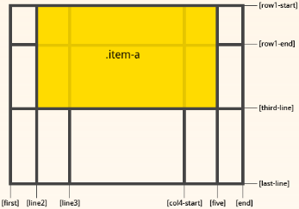
css
.item-b {
grid-column-start: 1;
grid-column-end: span col4-start;
grid-row-start: 2
grid-row-end: span 2
}
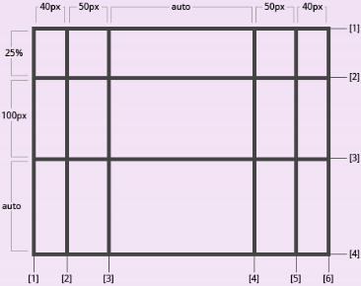

#grid-column, grid-row
Shorthand for grid-column-start + grid-column-end, and grid-row-start + grid-row-end, respectively.
Values:
- <start-line> / <end-line> - each one accepts all the same values as the longhand version, including span
css
.item-b {
grid-column: <start-line> / <end-line> | <start-line> / span <values>;
grid-row: <start-line> / <end-line> | <start-line> / span <values>;
}

Example:
css
.item-b {
grid-column: 3 /span 2;
grid-row: third-line / 4;
}
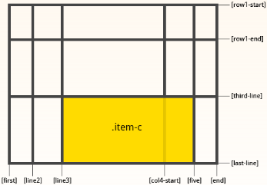
If no end line value is declared, the item will span 1 track by default.

#grid-area
Gives an item a name so that it can be referenced by a template created with the grid-template-areas property. Alternatively, this property can be used as an even shorter shorthand for grid-row-start + grid-column-start + grid-row-end + grid-column-end.
Values:
- <name> - a name of your choosing
- <row-start> / <column-start> / <row-end> / <column-end> - can be numbers or named lines
css
.item {
grid-area: <name> | <row-start> | <column-start> | <row-end> | <column-end>;
}

Example:
As a way to assign a name to the item:
css
.item-d {
grid-area: header
}

As the short-shorthand for grid-row-start + grid-column-start + grid-row-end + grid-column-end:
css
.item-d {
grid-area: 1 / col4-start / last-line 6
}
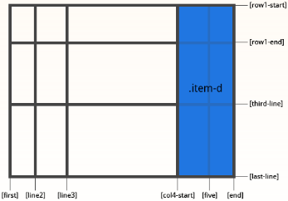

#justify-self
Aligns the content inside a grid item along the row axis (as opposed to align-self which aligns along the column axis). This value applies to the content inside a single grid item.
Values:
- start - aligns the content to the left end of the grid area
- end - aligns the content to the right end of the grid area
- center - aligns the content in the center of the grid area
- stretch - fills the whole width of the grid area (this is the default)
css
.item {
justify-self: start | end | center | stretch;
}

Example:
css
.item-a {
justify-self: start;
}
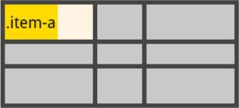
css
.item-a {
justify-self: end;
}
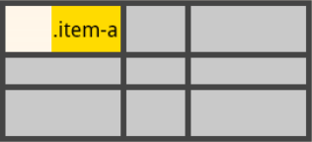
css
.item-a {
justify-self: center;
}
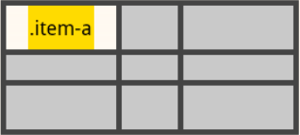
.item-a {
justify-self: stretch;
}
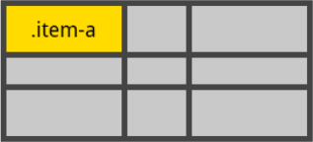
To set alignment for all the items in a grid, this behavior can also be set on the grid container via the justify-items property.

#align-self
Aligns the content inside a grid item along the column axis (as opposed to justify-self which aligns along the row axis). This value applies to the content inside a single grid item.
Values:
- start - aligns the content to the top of the grid area
- end - aligns the content to the bottom of the grid area
- center - aligns the content in the center of the grid area
- stretch - fills the whole height of the grid area (this is the default)
css
.item {
align-self: start | end | center | stretch;
}

Examples:
css
.item {
align-self: start;
}
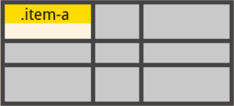
css
.item {
align-self: end;
}
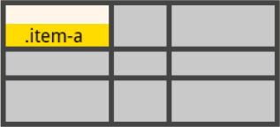
css
.item {
align-self: center;
}
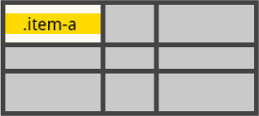
css
.item {
align-self: stretch;
}
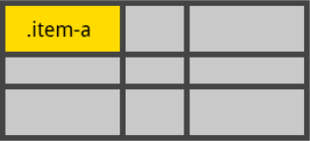
To align all the items in a grid, this behavior can also be set on the grid container via the align-items property.

